COCET English Manuscript Sample:
Subtitle
(1 line blank)

KOSEN Tsubasa^{1*}, COCET John^{2*}, SENMON Mizuho^{1*}, and ◦◦◦◦ ◦◦◦◦^{1*}
(1 line blank)

Abstract (in bold letters)

The abstract of the paper must be around 100 words in length. The font should be 10.5-point Century. The first line should be indented by 5 characters from the left margin, with all run-over lines right justified.

(1 line blank)
Keywords: Extensive reading, Writing, Rubric, Can-do list (in bold letters, up to four English words or phrases, with the first letter capitalized. Use commas for punctuation and leave two spaces for the next keyword.）
(1 line blank)
1. Title (in bold letters)

The first line should be indented by 5 characters from the left margin, with all run-over lines right justified. The font should be 10.5-point Century...
(1 line blank)

2. Title (in bold letters)

The first line should be indented by 5 characters from the left margin, with all run-over lines right justified. The font should be 10.5-point Century...
(1 line blank)
3. Title (in bold letters)
3.1. Subtitle (in bold letters)
The first line should be indented by 5 characters from the left margin, with all run-over lines right justified. The font should be 10.5-point Century...
(1 line blank)
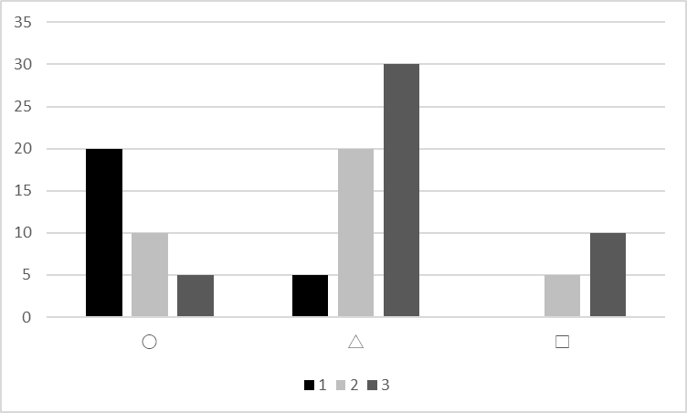
Table 1: Title

Figure 1: Title
(1 line blank)
Figures and tables should be in black and white, with large enough text and clear images; use 10.5-point Century, with title numbers such as “Table 1” and “Figure 1”, followed by a colon and a brief title. Place them at the bottom for figures and at the top for tables. Photographs and graphs should be treated as figures.
(1 line blank)
3.2. Subtitle (in bold letters)
The first line should be indented by 5 characters from the left margin, with all run-over lines right justified. The font should be 10.5-point Century…
(1 line blank)
In the block citation, the first line should be indented by 10 characters from the left margin, with all run-over lines right justified. The font should be 10.5-point Century (Cocet & Kosen, 2010: 124).
(1 line blank)
In case another block citation follows, leave one line blank between the citations. Again the first line should be indented by 10 characters from the left margin, with all run-over lines right justified. The font should be 10.5-point Century (Cocet, 2010: 125).
(1 line blank)
The first line should be indented by 5 characters from the left margin, with all run-over lines right justified. The font should be 10.5-point Century...

4. Title (in bold letters)
The first line should be indented by 5 characters from the left margin, with all run-over lines right justified. The font should be 10.5-point Century...
^{1*}(NIT, ◦◦◦◦ College, ◦◦◦◦ Campus) ^{2*}(◦◦◦◦ University)
(1 line blank)
Acknowledgements (in bold letters)
This work was supported by JSPS KAKENHI Grant Number JP12345678.
(1 line blank)
Notes (in bold letters)
1) Notes should be endnotes not footnotes...
2) In notes, the second and subsequent lines should be indented by 2 characters in “full-width” from the left margin. The font should be 10.5-point Century...
(1 line blank)
References (in bold letters)
Cocet, T. (2010). IT and language teaching. In S. Kosen (Ed.), Teaching Technical English in Japan (pp.123-134). Whitewell.
Cocet, T., & Kosen, J. (2010). IT and language teaching. EFL Journal in Japan, 35 (3), 123-134.
Morey, M.C. (2019). Physical Activity and Exercise in Older Adults. UpToDate. Retrieved July 22, 2019, from https://www.uptodate.com/contents/physical-activity-and-exercise/
井上英俊（2022）．「遠隔授業で実施する英単語テストの得点状況と受験者の印象－ケーススタディ－」『全国高等専門学校英語教育学会研究論集』第41号，175-184．
久保田佳克・岡﨑久美子・飯田清志・矢澤睦（2019）．「高専生の英語語彙サイズの変化と学習動機－仙台高専本科生の場合－」『全国高等専門学校英語教育学会研究論集』第38号，71-80.
篠村恭子・服部真弓（2021）．「高専での英語多読指導におけるオンライン記録媒体多読Moodle導入による指導者意識と指導の変容に関する質的研究」．https://doi.org/10.18983/caselejournal.51.0_1
全国高等専門学校英語教育学会（n.d.）．「COCETのあゆみ」http://cocet.org/history.html（最終検索日：2023年9月9日）
宮本友紀・藤田卓郎（2017）．「多言語環境で働く技術者の英語力に関するニーズ分析」．https://karin21.flib.u-fukui.ac.jp/repo/TL10096653
横川博一（2006）．「第10章 語彙と文法はいかに関連しているか」．門田修平・池村大一郎（編）『英語語彙指導ハンドブック』（pp. 259-271）．大修館書店．

